Due to the continuation of Covid and staffing issues, hours may be varied and reduced this year.
To be able to better serve you and help alleviate these problems, we are asking, please drop off your documents early or use the TTP secured online portal.

2021 Year End Newsletter
2021 Year End Newsletter

NEW and Updated Tax Laws for 2021

Charitable contributions. For 2021 only, a $300 charitable deductions is available for single filers who don’t itemize deductions on their tax return. This charitable deduction can be up to $600 for married filers. The limit for charitable contributions in 2021 is 100% of your income. The limit for noncash contributions is 50% of your income.
Standard Deductions
 | 2020 | 2021 | Change
Single | $12,550 | $12,400 | +$150
MFJ | 25,100 | 24,800 | +$300
HH | 18,800 | 19,650 | +$150
MFS | 12,550 | 12,400 | +$150
Elderly/Blind: married | +$1,350 | +$1,300 | +$50
Elderly/Blind: unmarried | +$1,700 | +$1,650 | +$50

THE TAX PLACE
300 N Milwaukee Ave Ste J
Lake Villa, IL 60046
224-701-6118
info@thetaxplaceillinois.com

Lifetime learning credit. The
Key Retirement Plan Limits
Plan | 2021 | 50+ Catchup
401K, 403b, 457 plans | $19,500 | +$6,500
IRA:Roth | $6,000 | +$1,000
IRA: Simple | $13,500 | +$3,000
IRA: Traditional | $6,000 | +$1,000
tuition and fees deduction was replaced with an expanded income limit for the Lifetime learning credit. The credit is worth up to $2,000 per tax return and covers many of the same costs as the now obsolete tuition and feed deduction.

Mileage Rates
 | 2021 | 2020 | Change
Business | 56₵ mile | 57.5₵ mile | -1.5₵
Medical/  Moving | 16₵ mile | 17₵ mile | -1₵
Charity | 14₵ mile | 14₵ mile | ---
Flexible spending accounts. Your employer may permit a 12-month grace period (up from 2 ½ months) for used balances as of December 31, 2021. This means that you could potentially roll over your entire unused FSA balance from 2021 to 2022.

Unemployment Compensation is fully taxable on 2021 Tax Returns. On your 2020 tax
return, you could exclude up to $10,200 ($20,400 married) of
unemployment compensation benefits.

Use our portal as a guest or ask us to create a profile for easy uploading and signing of documents at:
https://thetaxplace1.securefilepro.com

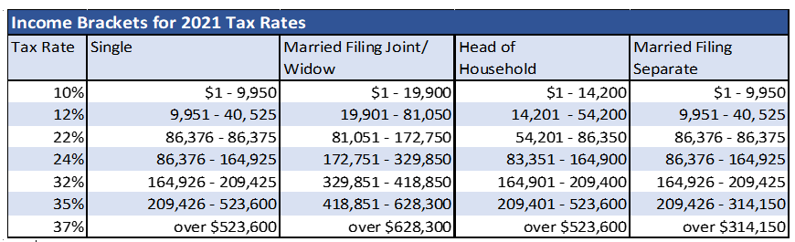
Get More Money for These Tax Credits in 2021

Child Tax Credit (CTC)
You can get up to $3,000 for kids ages 6-17 and $3,600 for kids ages 5 and under.
- To receive full tax credit, your adjusted gross income must be under $75,000 single; $150,000 married; or $112,500 head of household.
- If your income is above the thresholds, you can still receive $2,000 per child if your income is less than $200,000 single or HH; or $400,000 married joint.
- Be sure to add up any advance you received between July and December for the CTC so you can report it on your tax return.

Child and dependent care credit (DCC)

Cut your tax bill by up to $4,000 if you have 1 child or up to $8,000 if you have 2 or more kids with the DCC.
- You can claim up to $8,000 of dependent care expenses for 1 qualifying dependent and get a
- 50% tax credit, resulting in a maximum credit of $4,000.

- If you have more than 1 qualifying dependent you can claim up to $16,000 in dependent care expenses and get a 50% credit, resulting in a maximum credit of $8,000.
- You can only receive this credit if both you and your spouse, if married joint, are working and have adjusted gross income that doesn’t exceed $125,000.
- Dependents can include people of all aged, not just kids, as long as they meet the dependent qualification.

Earned Income tax credit

You can get an earned income tax credit of up to $1,502 if you’re a household with no kids. You must be
at least age 19 to claim the credit. You can also use either your 2019 income or your 2021 income when
calculating your credit to obtain the
maximum credit.

Common documents to bring to your appointment:
  - W2 wage
  - 1099R retirement
  - 1099INT & 1099DIV
  - 1099B investments
  - SSA-1099 social security
  - 1099G unemployment
  - Business income, 1099NEC, K1’s,
  - W-2G gambling
  - 1099 SA- HSA distributions
- 1098 Mortgage
- Real Estate Tax paid
- 1098T College tuition
- 1098E student loan
Interest
- Charity Donations
- IRA contributions
- K-12 school fees
- Business expenses
- Daycare Info & Amount
- Medical over 7 ½% of AGI
- SS# & DOB for everyone on the return
- Bank info.
- Stimulus
    - Third EIP amount
    - Advanced child tax credit
- Driver’s License

