Each year thieves try to steal billions by stealing your identity. As the IRS focuses more attention on this quickly growing problem, now is the time to learn how to protect your identity during the 2021 tax season that begins in January 2022.

Early tax filing season is the worst time for theft.
Thieves will try to file a fraudulent tax return before you have time to submit your own at the start of filing season. If you have a tax refund coming, the thieves can steal your money and be long gone by the time you file your own tax return. So, what can you do?

- File Early. The sooner you file your return, the less likely a thief will beat you to your refund.

- Consider an Identity Protection PIN. Taxpayers who can verify their identity can get an Identity Protection PIN (IP PIN) from the IRS. The IP PIN is a six-digit code known only to you and the IRS that helps prevent identity thieves from filing fraudulent tax returns. Once registered, you will receive a new IP PIN each year to file your taxes.

- Check your credit reports. See if there is any suspicious activity on your accounts and on your credit reports.

- Protect your ID. Be suspicious. Never give out your Social Security number, do not leave your credit card unattended, never give ID information to someone who calls you, use the password function of your phone, be aware of strange mail, and shred important documents. Your best defense to IRS ID theft is to use best practices to protect your information.

- Put a freeze, hold, or lock on your credit.

Credit Reporting Companies

Equifax TransUnion
Phone: 866-349-5191 Phone: 833-395-6938
Mail: P.O. Box 105788, Atlanta, GA 30348 Mail: P.O. Box 2000, Chester, PA 19016

Experian
Phone: 888-EXPERIAN (397-3742)
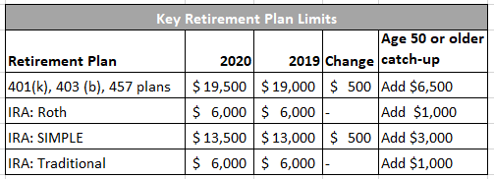
Mail: P.O. Box 9554, Allen, TX 75013

